Spring security :

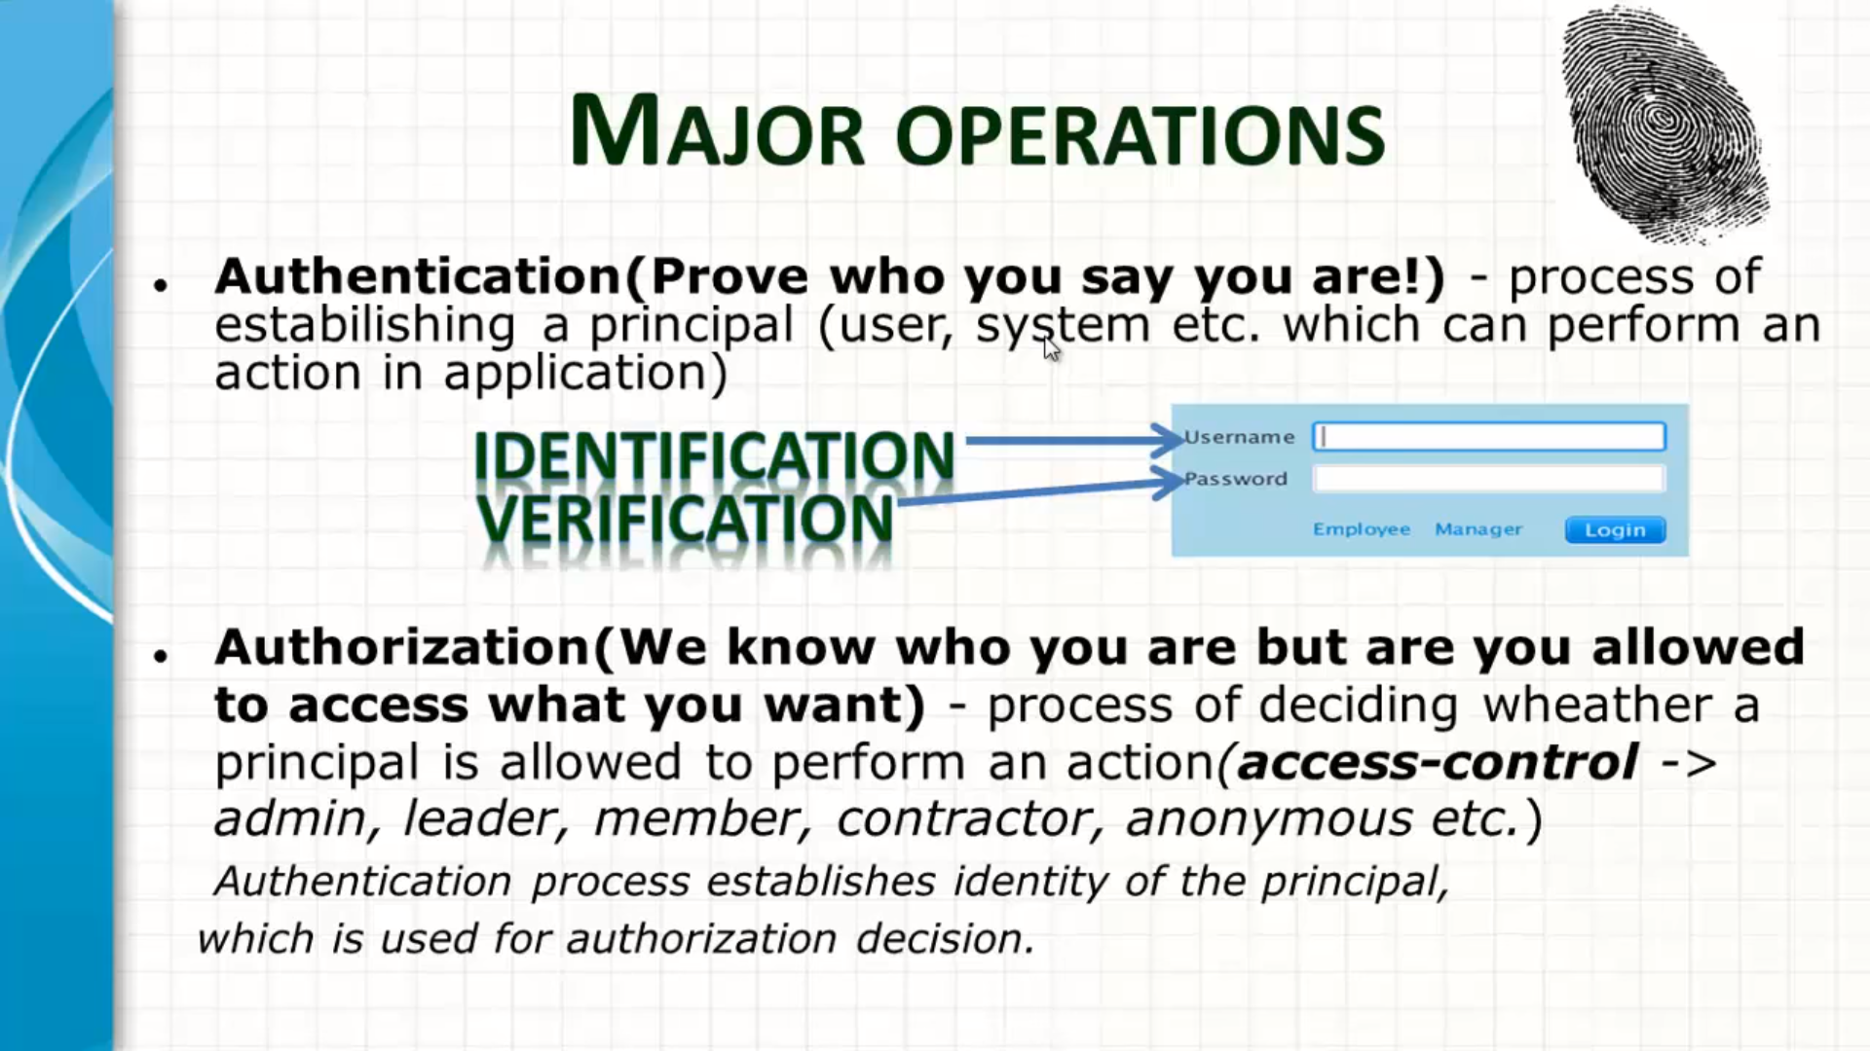

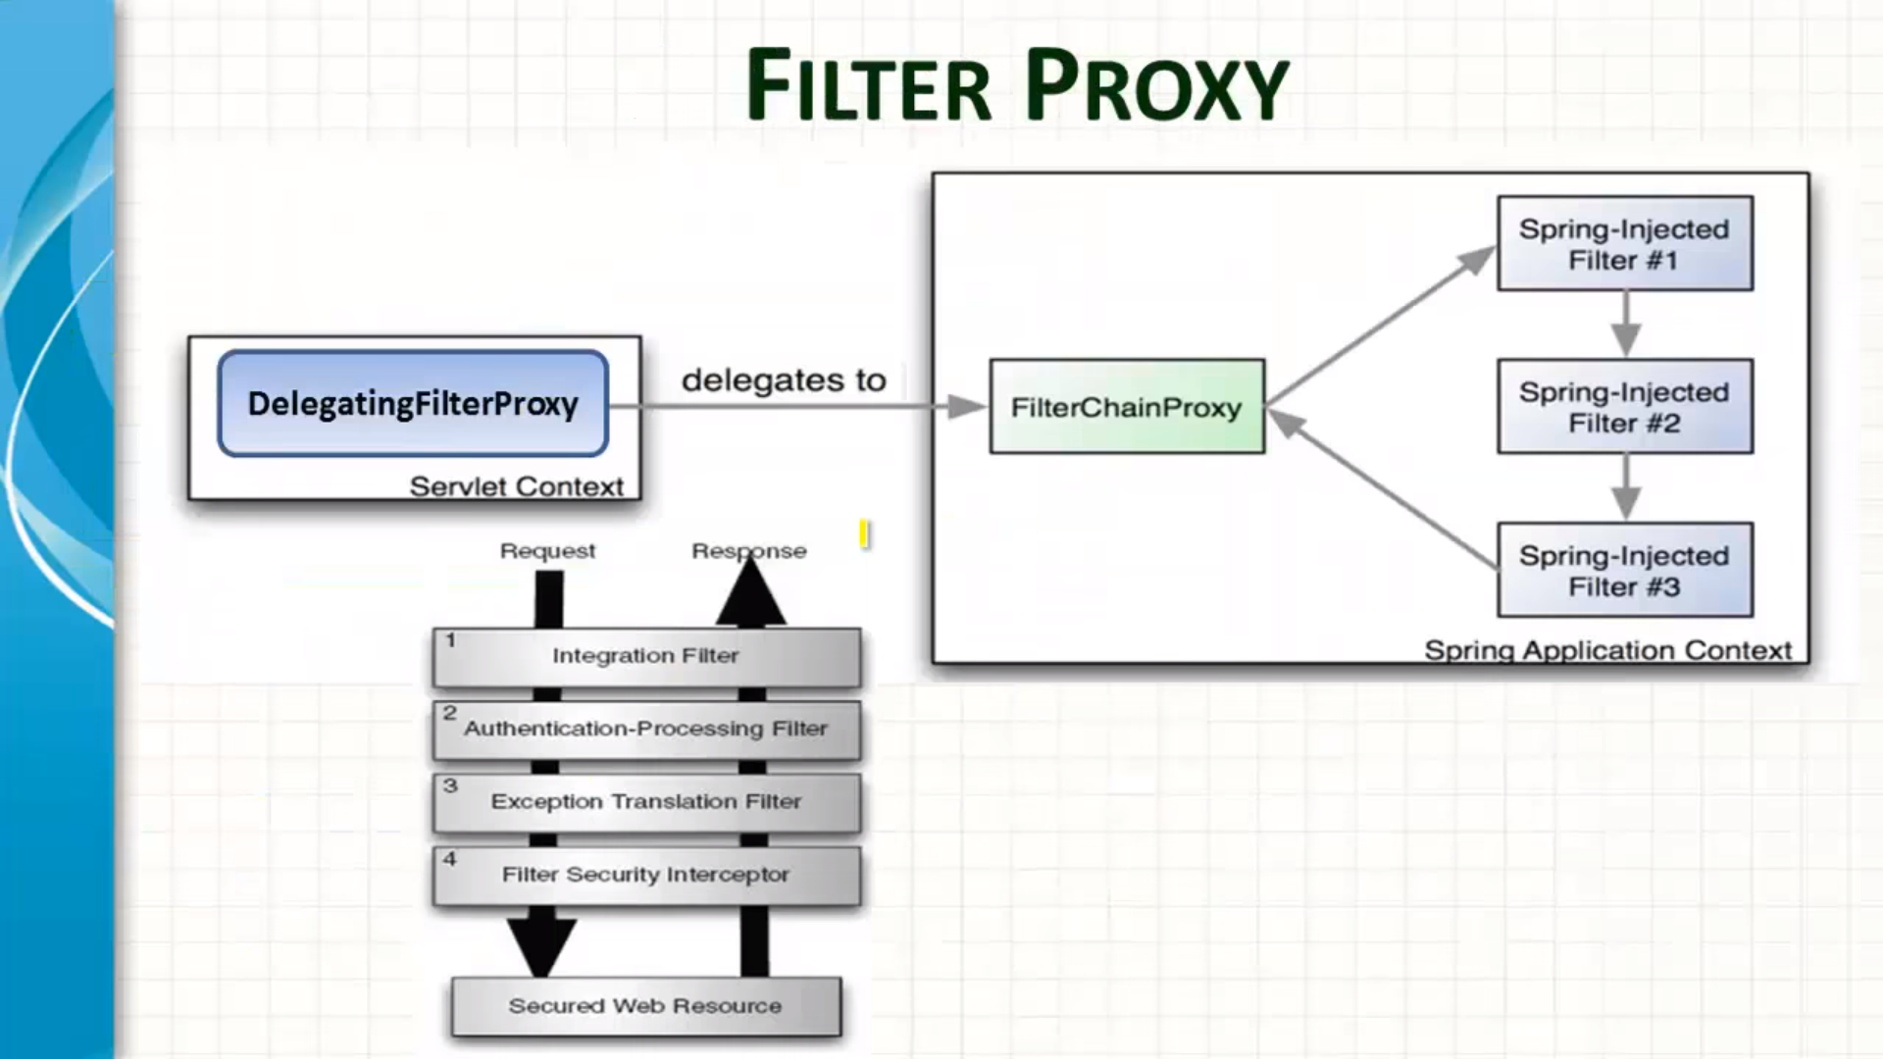

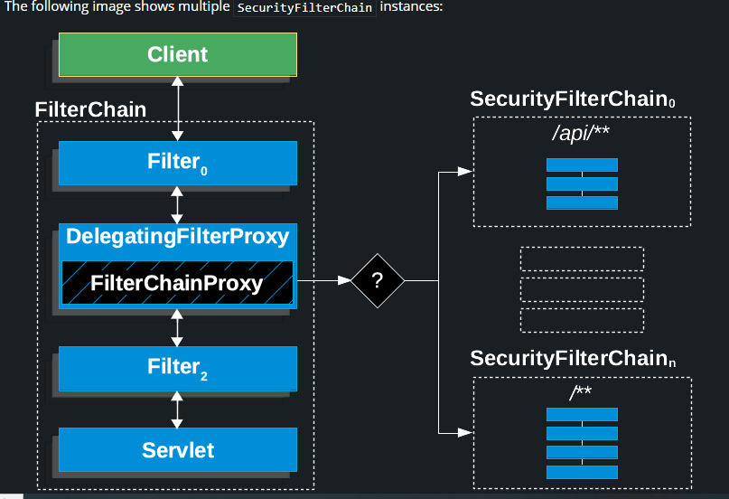

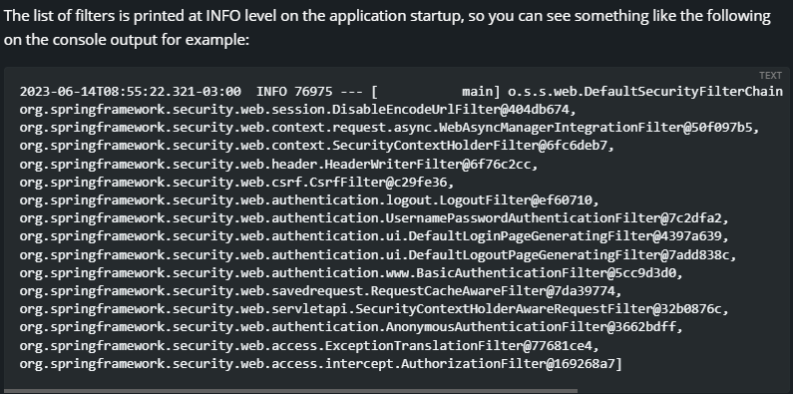

**How to register custom filter**

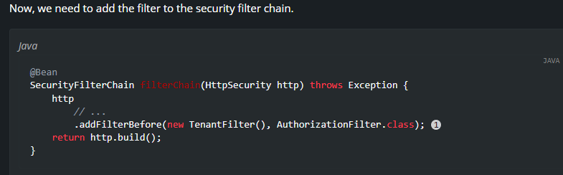

Be careful when you declare your filter as a Spring bean, either by annotating it with @Component or by declaring it as a bean in your configuration, because Spring Boot will automatically register it with the embedded container. That may cause the filter to be invoked twice, once by the container and once by Spring Security and in a different order.

@Bean

public FilterRegistrationBean<TenantFilter> tenantFilterRegistration(TenantFilter filter) {

FilterRegistrationBean<TenantFilter> registration = new FilterRegistrationBean<>(filter);

registration.setEnabled(false);

return registration;

}

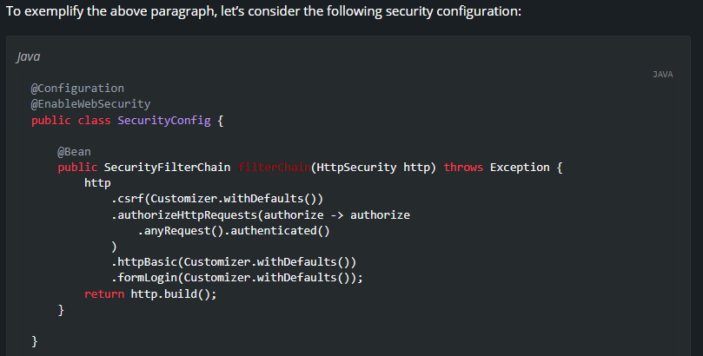

**AbstractAuthenticationProcessingFilter**

[AbstractAuthenticationProcessingFilter](https://docs.spring.io/spring-security/site/docs/6.1.2/api/org/springframework/security/web/authentication/AbstractAuthenticationProcessingFilter.html) is used as a base Filter for authenticating a user’s credentials. Before the credentials can be authenticated, Spring Security typically requests the credentials by using [AuthenticationEntryPoint](https://docs.spring.io/spring-security/reference/servlet/authentication/architecture.html#servlet-authentication-authenticationentrypoint).

Next, the AbstractAuthenticationProcessingFilter can authenticate any authentication requests that are submitted to it.

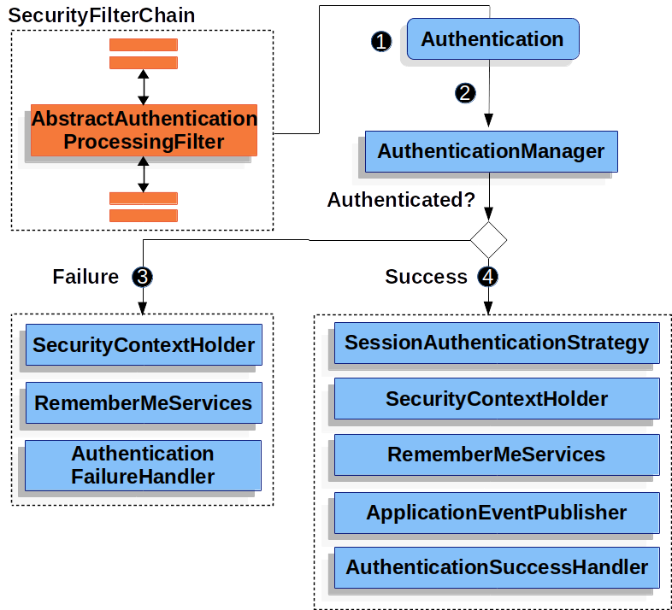

 When the user submits their credentials, the AbstractAuthenticationProcessingFilter creates an [Authentication](https://docs.spring.io/spring-security/reference/servlet/authentication/architecture.html#servlet-authentication-authentication) from the HttpServletRequest to be authenticated. The type of Authentication created depends on the subclass of AbstractAuthenticationProcessingFilter. For example, [UsernamePasswordAuthenticationFilter](https://docs.spring.io/spring-security/reference/servlet/authentication/passwords/form.html#servlet-authentication-usernamepasswordauthenticationfilter) creates a UsernamePasswordAuthenticationToken from a *username* and *password* that are submitted in the HttpServletRequest.

 Next, the [Authentication](https://docs.spring.io/spring-security/reference/servlet/authentication/architecture.html#servlet-authentication-authentication) is passed into the [AuthenticationManager](https://docs.spring.io/spring-security/reference/servlet/authentication/architecture.html#servlet-authentication-authenticationmanager) to be authenticated.

 If authentication fails, then *Failure*.

* The [SecurityContextHolder](https://docs.spring.io/spring-security/reference/servlet/authentication/architecture.html#servlet-authentication-securitycontextholder) is cleared out.
* RememberMeServices.loginFail is invoked. If remember me is not configured, this is a no-op. See the [rememberme](https://docs.spring.io/spring-security/site/docs/6.1.2/api/org/springframework/security/web/authentication/rememberme/package-frame.html) package.
* AuthenticationFailureHandler is invoked. See the [AuthenticationFailureHandler](https://docs.spring.io/spring-security/site/docs/6.1.2/api/org/springframework/security/web/authentication/AuthenticationFailureHandler.html) interface.

 If authentication is successful, then *Success*.

* SessionAuthenticationStrategy is notified of a new login. See the [SessionAuthenticationStrategy](https://docs.spring.io/spring-security/site/docs/6.1.2/api/org/springframework/security/web/authentication/session/SessionAuthenticationStrategy.html) interface.
* The [Authentication](https://docs.spring.io/spring-security/reference/servlet/authentication/architecture.html#servlet-authentication-authentication) is set on the [SecurityContextHolder](https://docs.spring.io/spring-security/reference/servlet/authentication/architecture.html#servlet-authentication-securitycontextholder). Later, if you need to save the SecurityContext so that it can be automatically set on future requests, SecurityContextRepository#saveContext must be explicitly invoked. See the [SecurityContextHolderFilter](https://docs.spring.io/spring-security/site/docs/6.1.2/api/org/springframework/security/web/context/SecurityContextHolderFilter.html) class.
* RememberMeServices.loginSuccess is invoked. If remember me is not configured, this is a no-op. See the [rememberme](https://docs.spring.io/spring-security/site/docs/6.1.2/api/org/springframework/security/web/authentication/rememberme/package-frame.html) package.
* ApplicationEventPublisher publishes an InteractiveAuthenticationSuccessEvent.
* AuthenticationSuccessHandler is invoked. See the [AuthenticationSuccessHandler](https://docs.spring.io/spring-security/site/docs/6.1.2/api/org/springframework/security/web/authentication/AuthenticationSuccessHandler.html) interface.

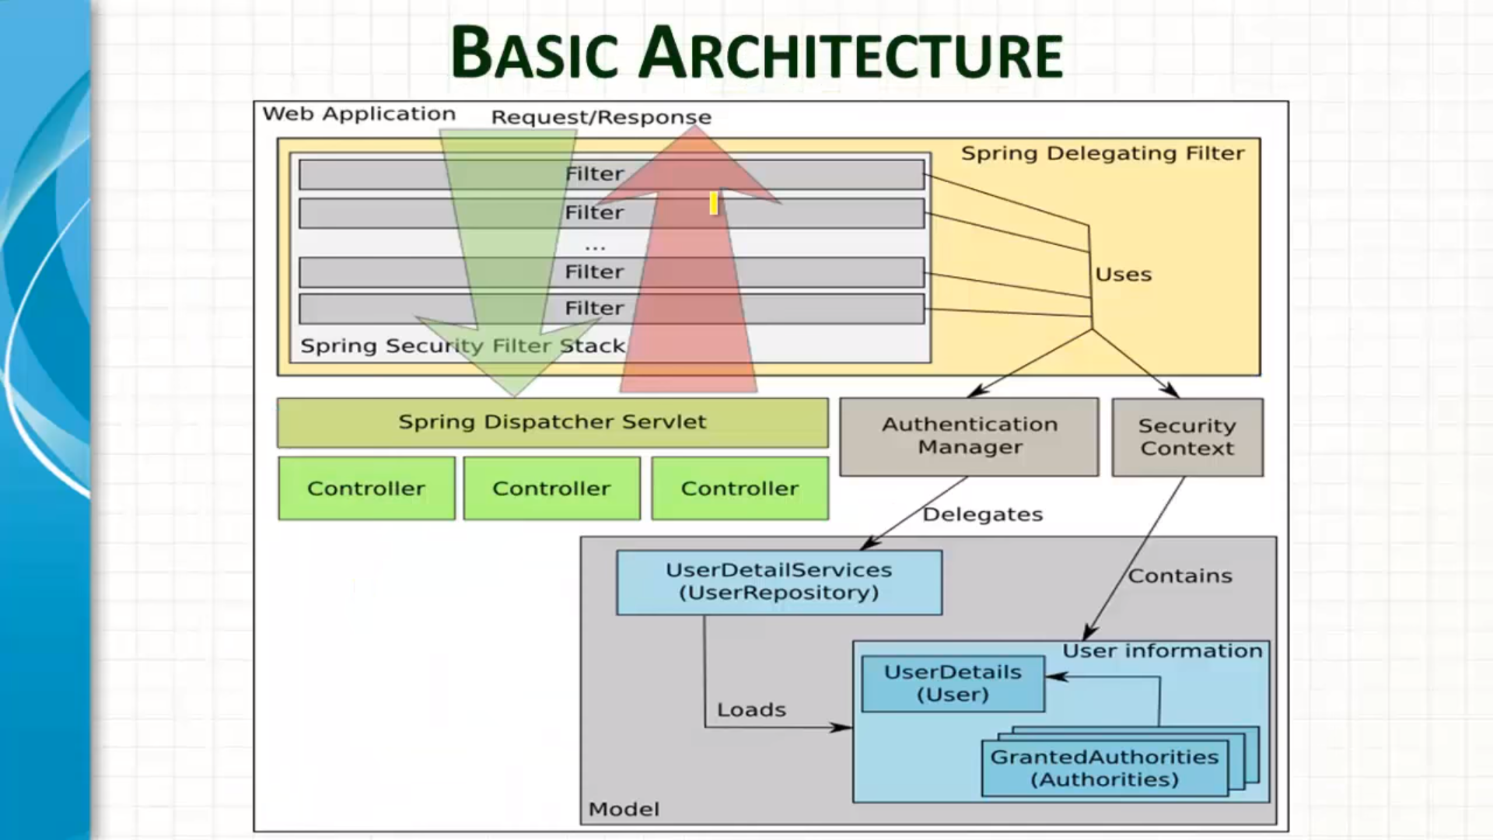

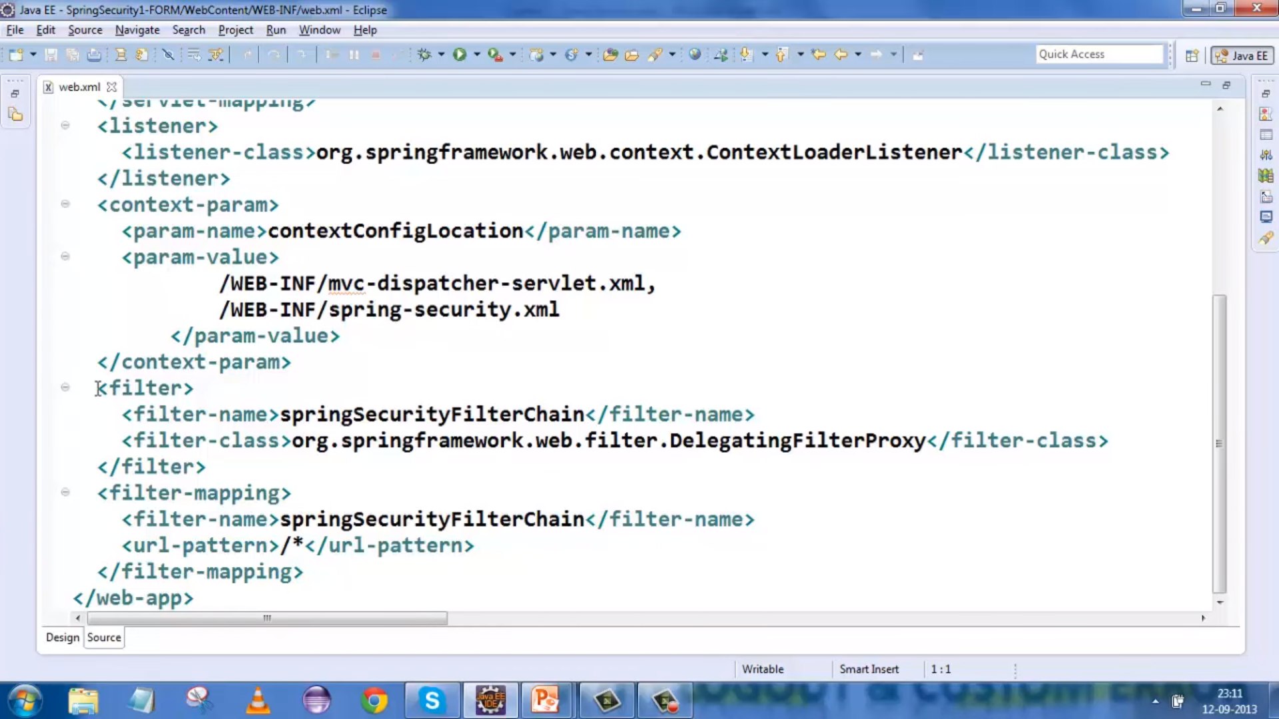

Basic & Form Security :

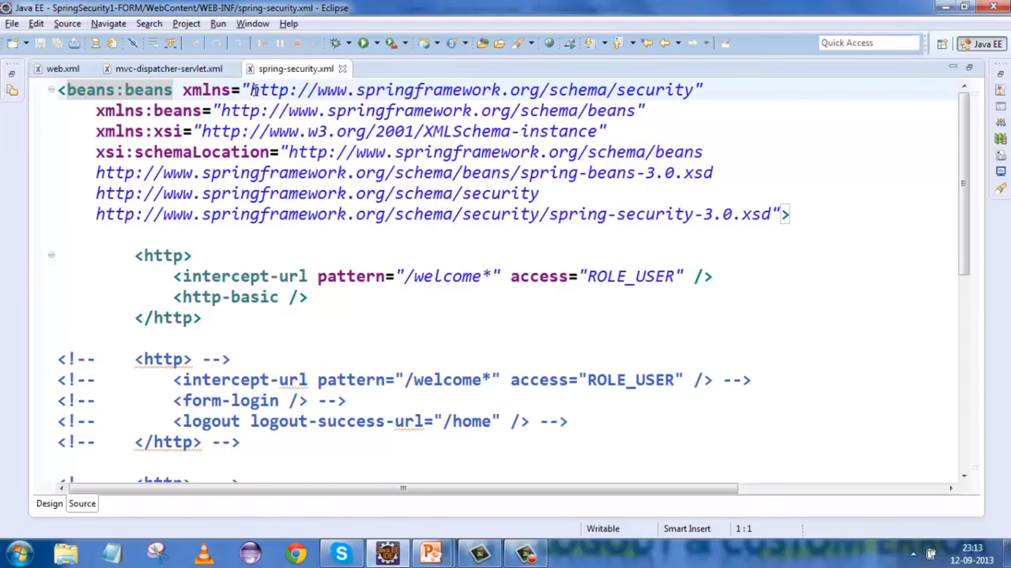

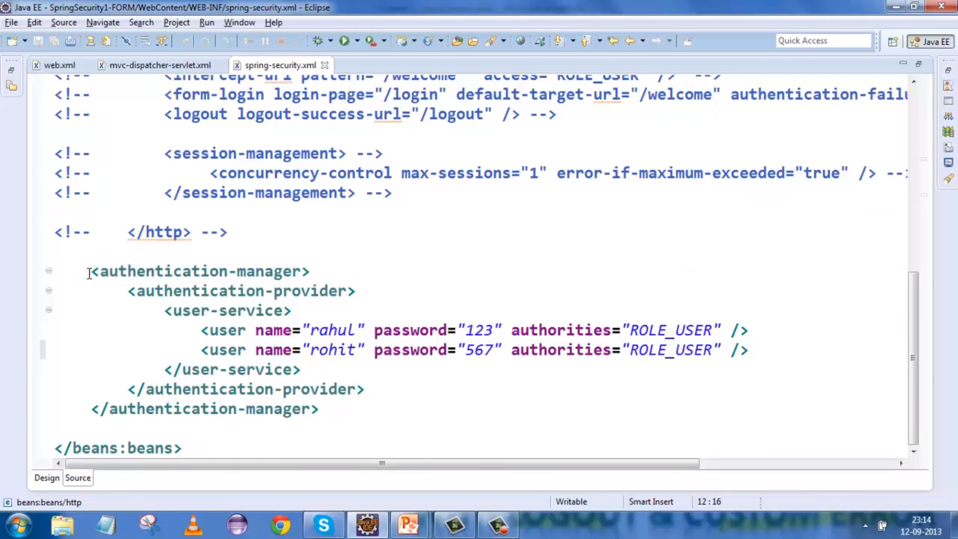

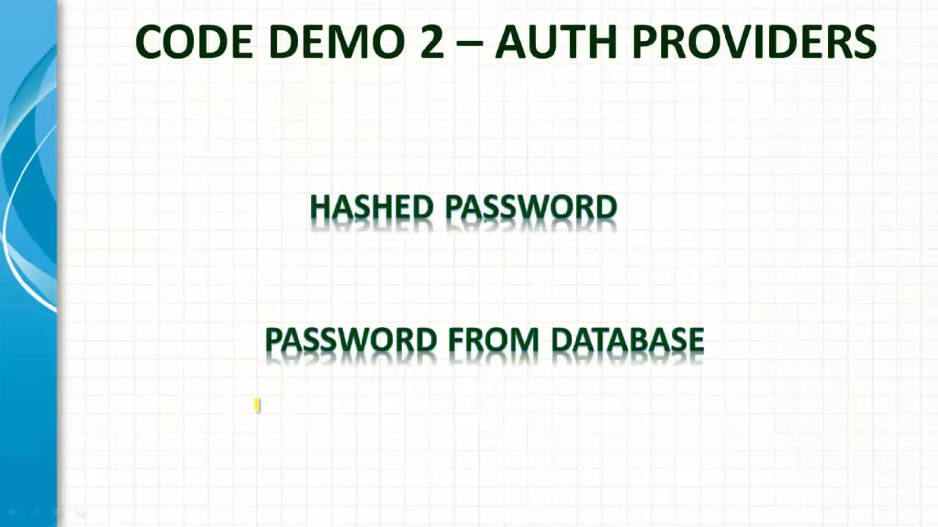

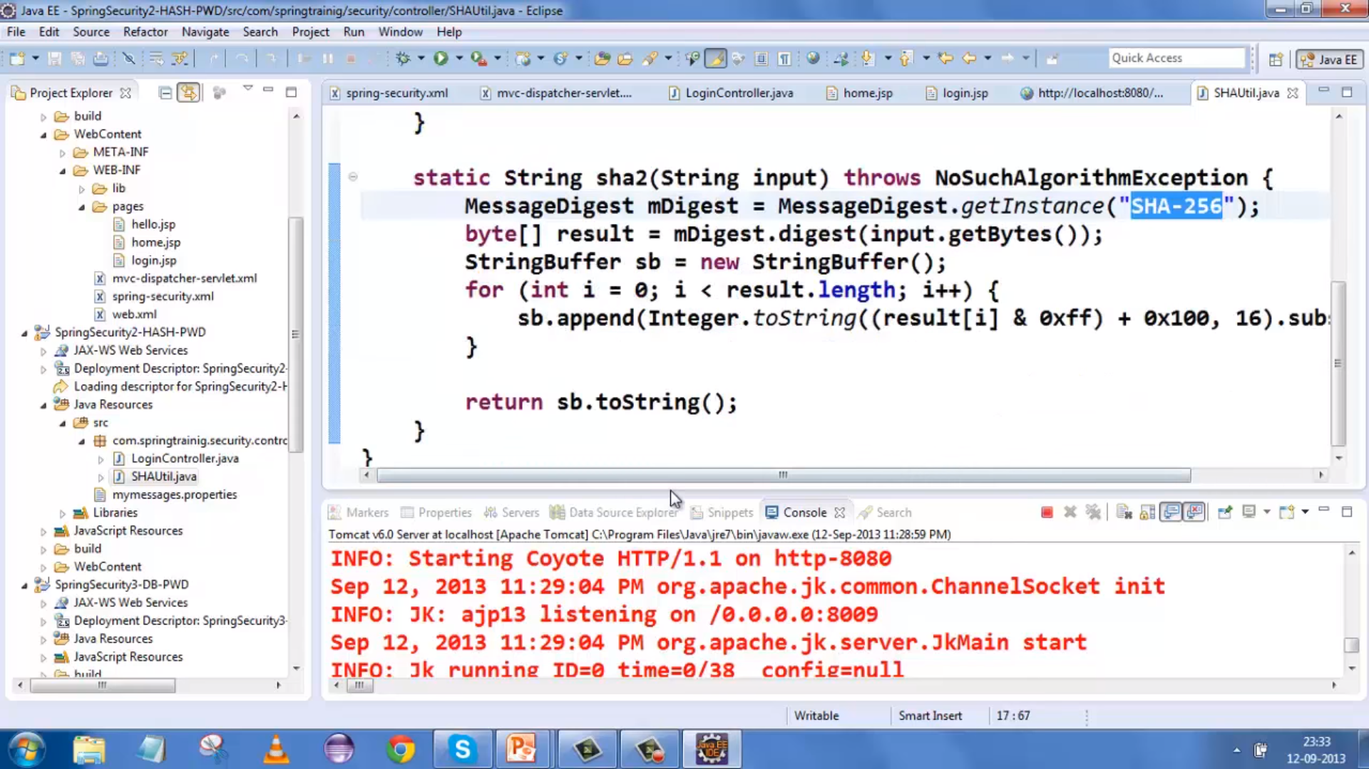

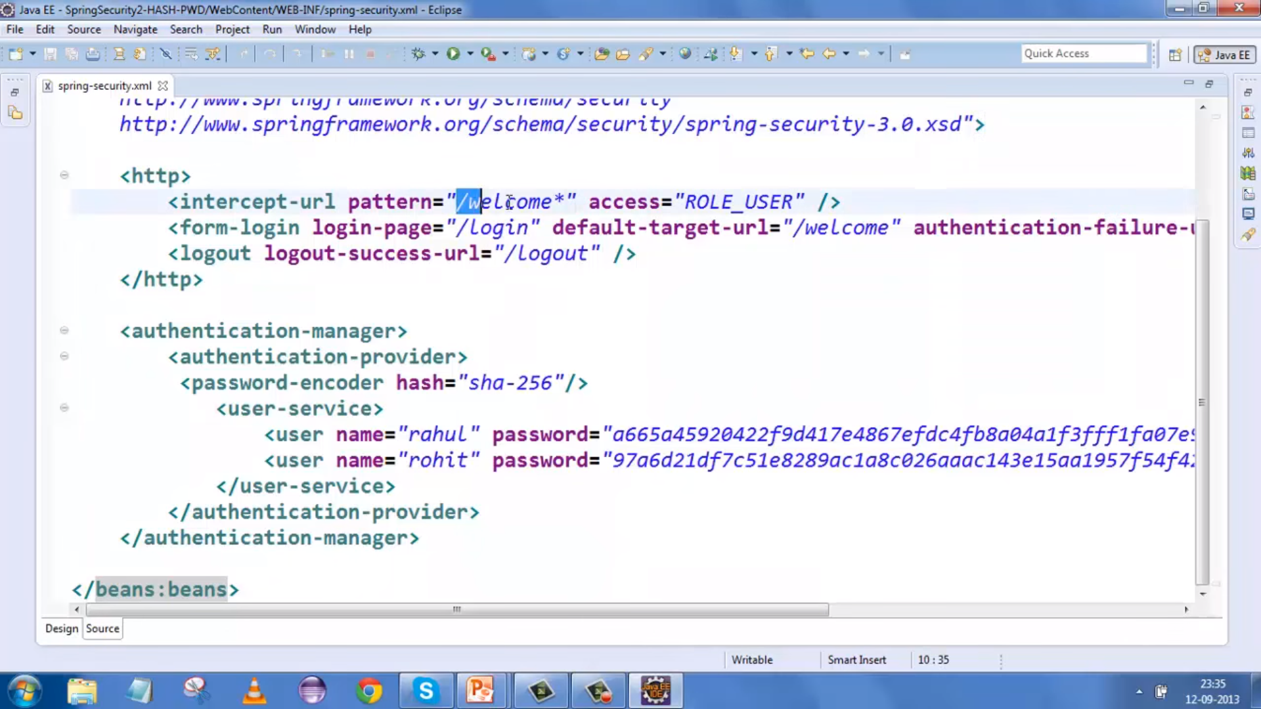

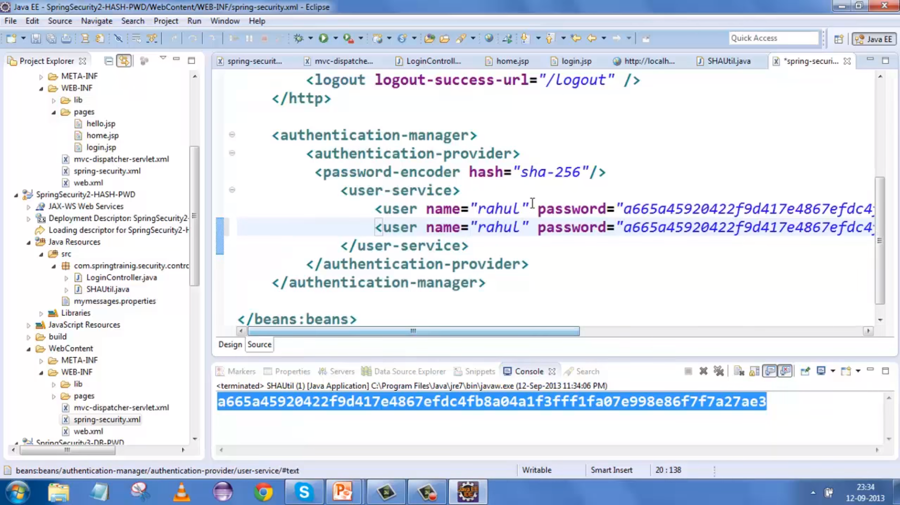

User Name & PWD from DB :

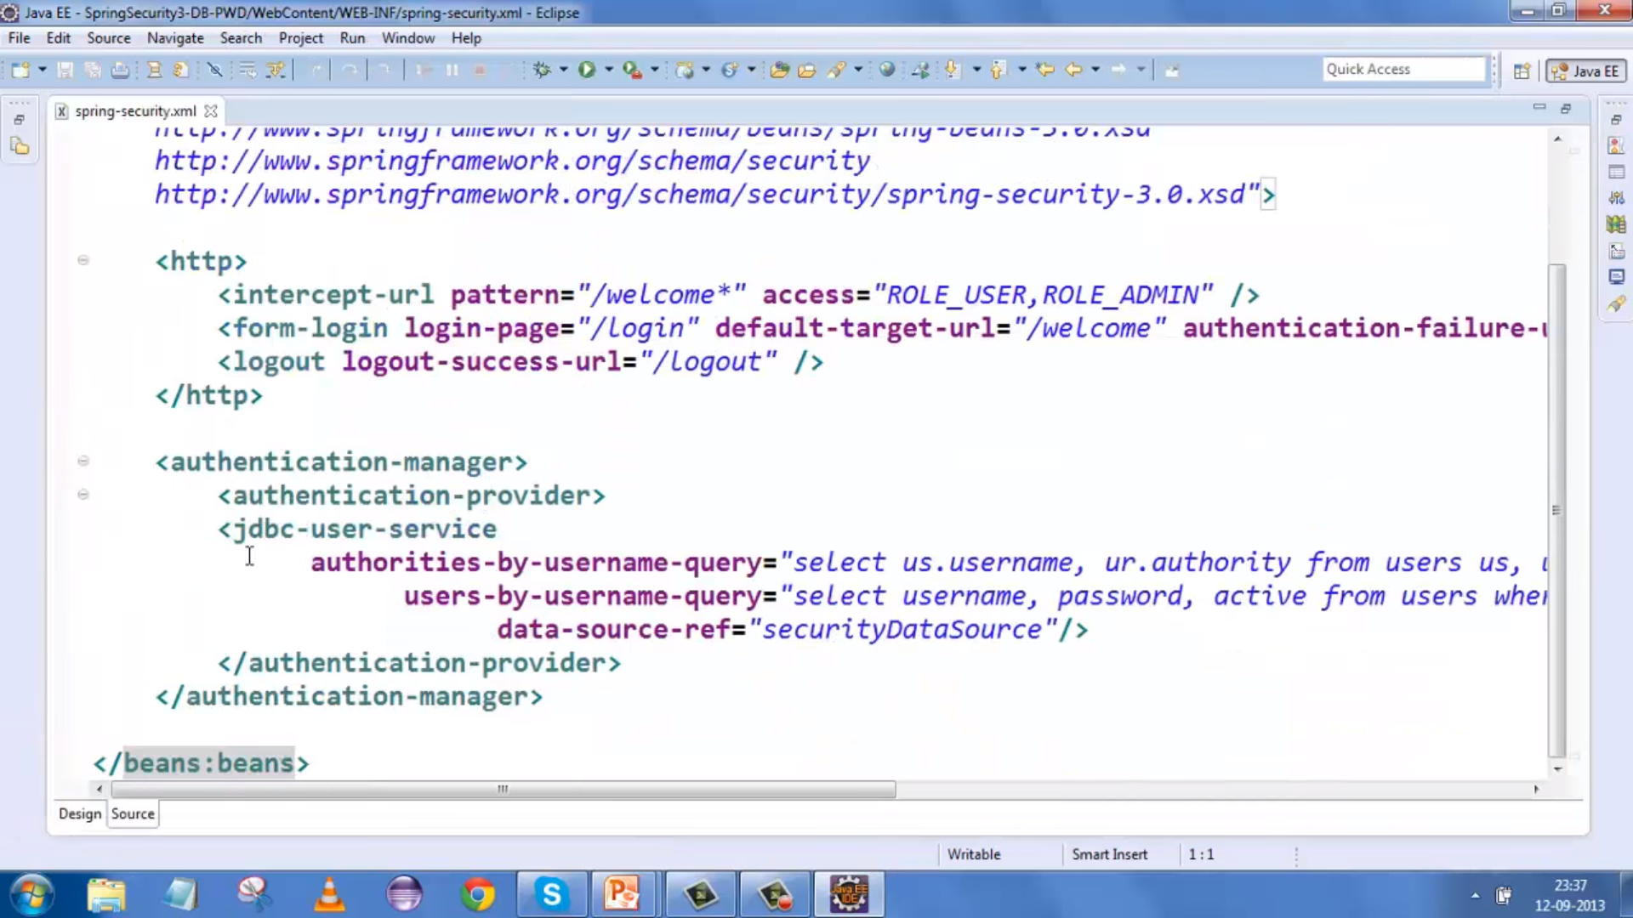

Authorization :

